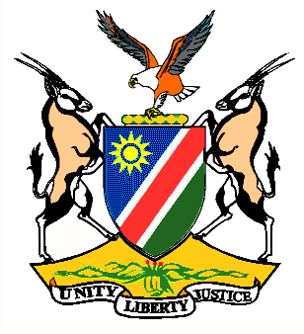

EMBASSY/PERMANENT MISSION OF THE REPUBLIC OF NAMIBIA

REPUBLIC OF NAMIBIA

Statement by H.E. Sabine Böhlke-Möller, Permanent Representative during the Interactive Dialogue on the Universal Periodic Review of the United Republic of Tanzania, 09 May 2016, 09h00 – 12h30

Mr. President,
Namibia welcomes the delegation of the United Republic of Tanzania to this Session of the UPR and commends them on the presentation of their national report.
Tanzania has made significant strides in the area of law reform and development during the period under review and Namibia is pleased to take note of the large number of laws adopted and the fact that these laws are all translated into the Swahili language.
We are also pleased to notice the adoption of the National Human Rights Action Plan in 2013 and the processes incorporated therein, amongst others the implementation of UPR recommendations.
We would like to know from the delegation if they can share any feedback with us in the form of lessons learnt on the National Action Plan for Prevention and Eradication of Violence against Women and Children, for the period ending in 2015.
Namibia would like to recommend:
1. That the Government of Tanzania considers ratification of the Second Optional Protocol to the ICCPR with a view to abolish the death penalty and to establish an official moratorium on the death penalty.
2. That the government of Tanzania continues to take active measures to eliminate gender gaps in human development and gender-based inequalities in reproductive health, empowerment and economic activity.
We wish Tanzania all the best during their review.
I thank you Mr. President.

